RW228A/1204C, RW228B/1204C



DUBLIN INSTITUTE OF TECHNOLOGY
_____________

DT228A/1 MSc in Computing
DT228B/1 MSc in Computing
______________

SUPPLEMENTAL EXAMINATIONS 2015/2016
______________

Probability and Statistical Inference [Math9100]

Ms. deirdre Lawless
Dr. Deirdre Lillis
Mr. Conor sayles

date & Time TBA

Two Hours

Instructions to candidates

Answer question one and one other question.

All questions carry equal marks.

1. |  | A researcher is currently researching hospital care in Ireland. They have developed a theory as part of their research that the length of patient stay in hospital can be predicted by the average number of beds available and nurses on duty in the hospital on the day the patient entered hospital. Their intention is to conduct a statistical analysis of this dataset so that they can extrapolate their findings to all major hospitals in Ireland.  A dataset comprising 114 cases, each representing a single patient, was constructed by conducting an audit of patients discharged during one week from a single hospital. The variables collected are described in the table below. The hospital can deal with 514 patients when operating at maximum capacity and is the second largest hospital in the country and is located in the capital city. There are currently 15 major hospitals operating in the country with similar capacities, two located in the capital but all others located in areas that significantly smaller population sizes than the capital city. The gender ratio in the country is 50:50 male:female. Missing data is not a concern.  Traditionally a 5% cut-off level of statistical significance is used within the research domain.  Question One is continued on next page
  Variables of concern in the dataset
  Name | Label | Comment | Type
  Length | Length of patient stay in hospital |  | Scale
  Gender | Patient gender | 1=male, 2 = female | Categorical
  Age | Patient age |  | Scale
  InfectRsk | Risk of developing an infection | 1=low, 2= high | Categorical
  Beds | Number of beds available on patient admission |  | Scale
  Nurses | Number of nurses on duty on patient admission |  | Scale
  ZLength | ZScore length of patient stay |  | Scale
  Zbeds | ZScore number beds available |  | Scale
  Znurses | ZScore number nurses on duty |  | Scale

1. | (a) | - Discuss the suitability of the dataset collected for use in the proposed research.  Comment in particular on the representativeness of the sample and consider the concepts of statistical significance and the role probability plays in this, statistical power, Type I and Type II errors. Identify mechanisms that the researcher could use to address issues you identify.  (18 marks)  - Examine the information provided on the variables length of patient stay, number of beds available and number of nurses on duty.  Using the information provided in Appendix A, discuss their central tendency, dispersion, in particular skewness and kurtosis. Explain each concept and discuss their impact on the proposed research as well as mechanisms that could be used to address issues identified so that the data could be used in the proposed research.  (18 marks)
 | (b) | Explain what is required to assert that there is a causal relationship between two variables. Illustrate your answer by using the results of the relevant test provided in Appendix A, to interpret the relationship between length of patient stay and number of beds available, length of patient stay and number of nurses on duty, and length of patient stay and gender.  (14 marks)

2. | (a) | The researcher has created a variable znormlength which is a standardised score for length of stay in hospital which has a standard normal distribution. They have decided to use linear regression to explore the relationship between this score and the standardised score for the number of beds available zbeds. The researcher first created a simple linear regression model.  Explain what in this context prediction means. Illustrate your answer by using the additional statistics provided in Appendix B to interpret the model and assess the fit and usefulness of the model considering the coefficients, R², Adjusted R²and F statistic.  (15 marks)
 | (b) | Differences in the length of stay for different categories of infection risk have been found. Suppose the researcher has extended the model to include infection by incorporating a dummy variable dummyInfect which has a value 0 for low and 1 for high.  - Explain clearly why a dummy variable is needed before using the information provided in Appendix B to state the regression equation, interpret this second model for both low and high risk categories and assess its fit and compare it to the model created in part (a).  (15 marks)  - Assess the output for multicollinearity and outliers explaining why these are concerns for multiple linear regression and how you could address these concerns.  (10 marks)
 | (c) | The researcher wishes to investigate whether there is an interaction effect between age and infection risk category. They have included an additional variable in the dataset IntAgeRisk which is a combination of age and infection risk category and included this in the regression model created for part (b). The output is shown in Appendix B.  Discuss what an interaction effect is and how it can be assessed using multiple linear regression. Illustrate your answer by referring to the output of the model created, briefly commenting on the fit of the model created and how the new term affects the model.  (10 marks)

3. |  | A researcher has collected data on patient attitudes about their hospital experience. They conducted a survey using a recognised attitudinal scale which has been found to be reliable. They wish to incorporate a single measure of patient satisfaction with their experience. They wish to conduct a PCA on these variables to create this measure. The dataset contains 254 cases.  - Explain clearly the objectives of principal component analysis (PCA) and when you would use this technique.  (6 marks)
  Variable Name | Label | Values
  perf_1 | Performance: Good standard of care | 1(Extremely Good) to 10 (Extremely Poor)
  perf_2 | Performance: Good value for money | 1(Extremely Good) to 10 (Extremely Poor)
  perf_3 | Performance: Good availability of staff | 1(Extremely Good) to 10 (Extremely Poor)
  perf_4 | Performance: Bills are clear | 1(Extremely Good) to 10 (Extremely Poor)
  perf_5 | Performance: Convenient Visiting Hrs | 1(Extremely Good) to 10 (Extremely Poor)
  perf_6 | Performance: Good hospital to be in | 1(Extremely Good) to 10 (Extremely Poor)
- Discuss the suitability of the dataset. In your answer, using the information provided in Appendix C, you should in particular examine the descriptive statistics on each of these variables, details of correlations between them and the reliability of the scale to determine if PCA is possible.
(18 marks)
Explain how PCA works focusing on extraction and loading. Illustrate your answer by interpreting the output of the PCA conducted for this research using the information provided in Appendix C.
(20 marks)
Briefly explain the differences between PCA and exploratory factor analysis.
(6 marks)

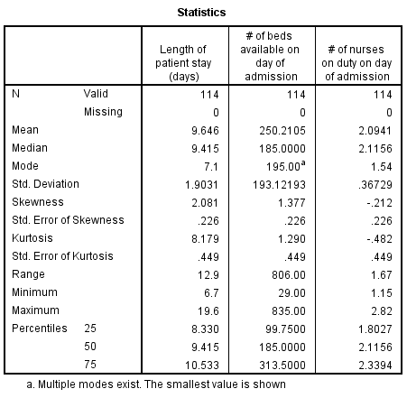 | 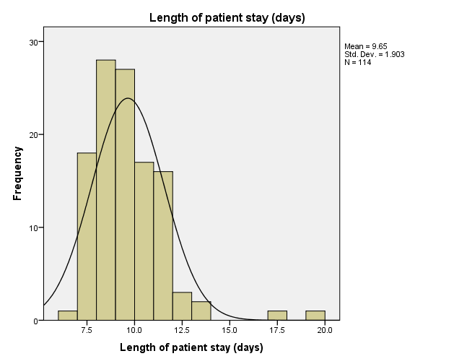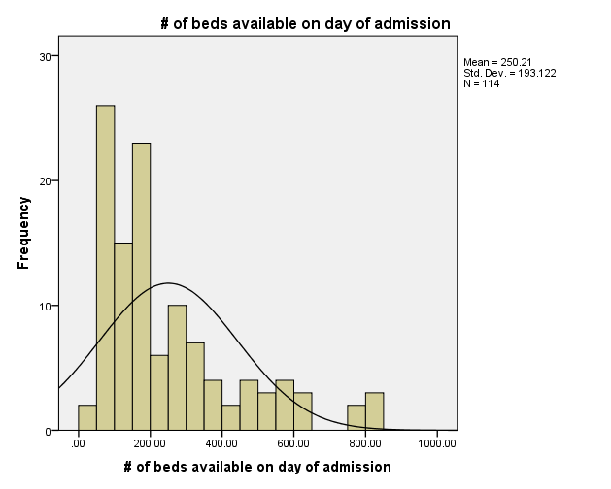  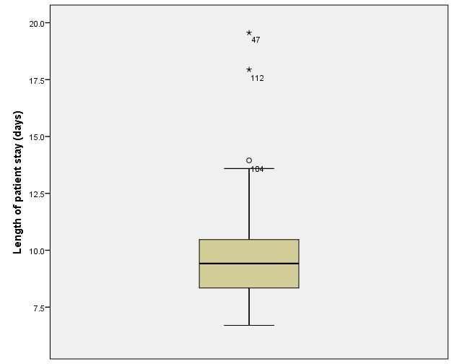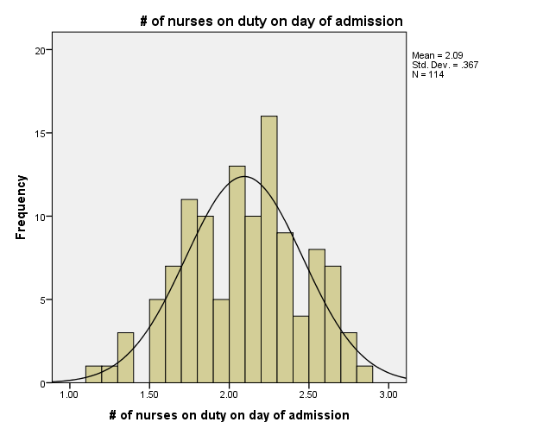
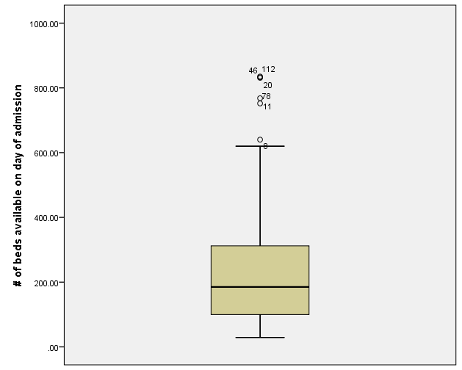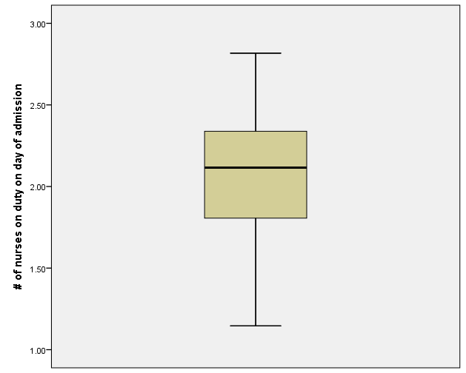
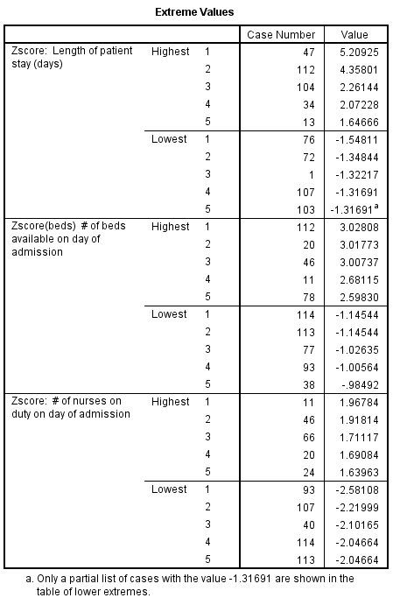 | 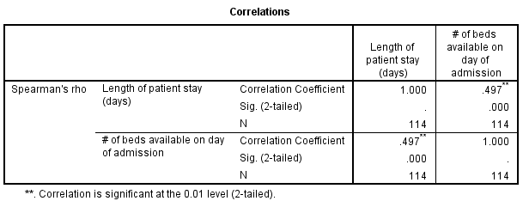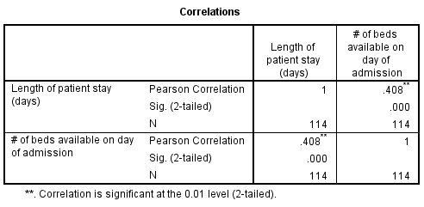

Model for Q2(a) |  | Model for Q2(b)
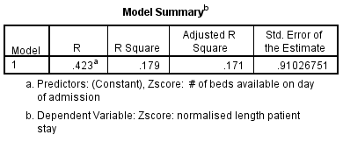 |  | 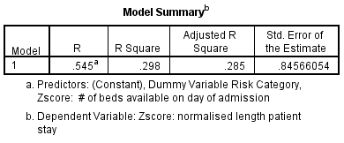
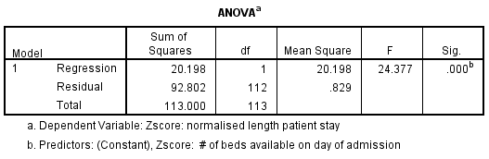 |  | 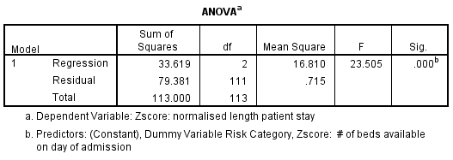
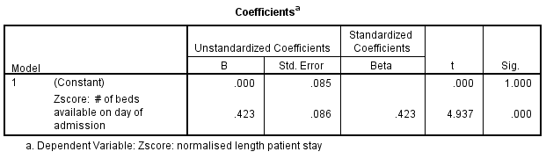
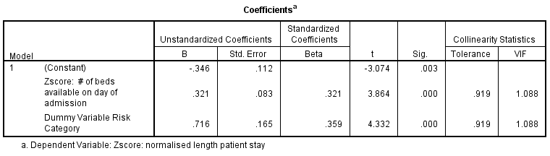
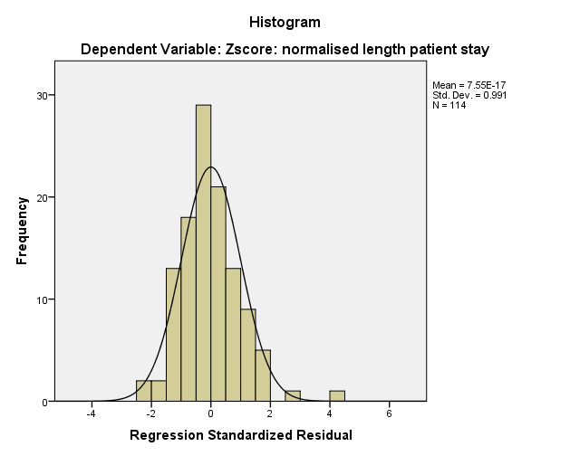 | 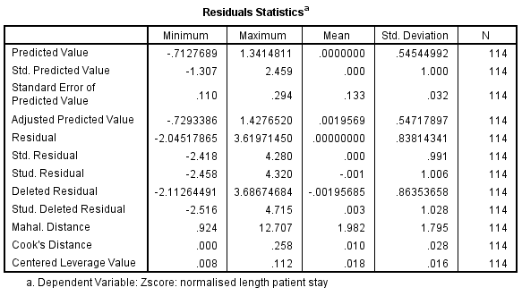
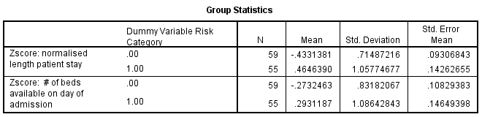
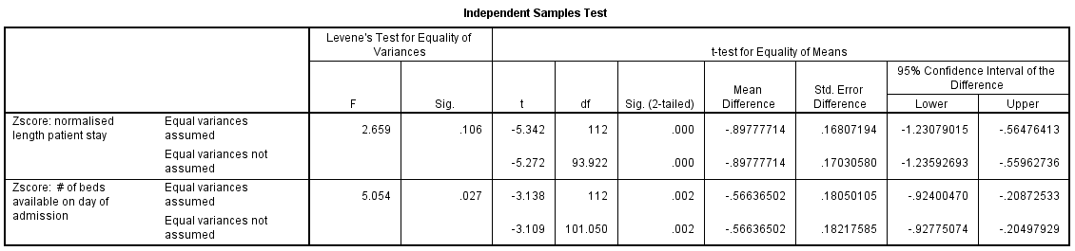

Model for 2 (c)
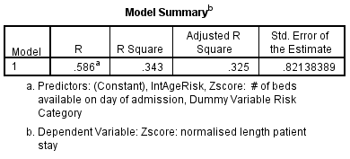 | 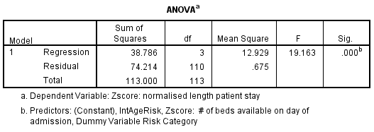
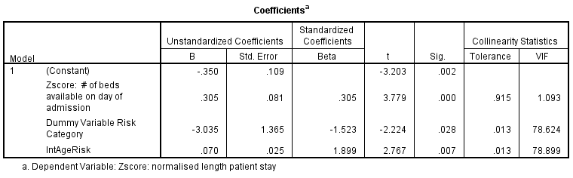

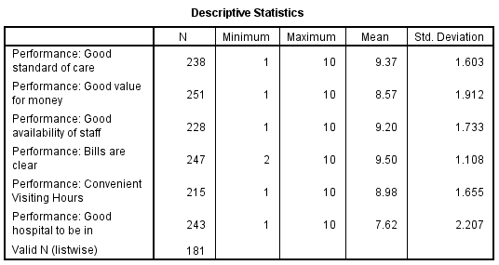 |  | 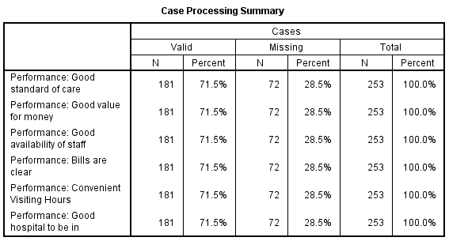
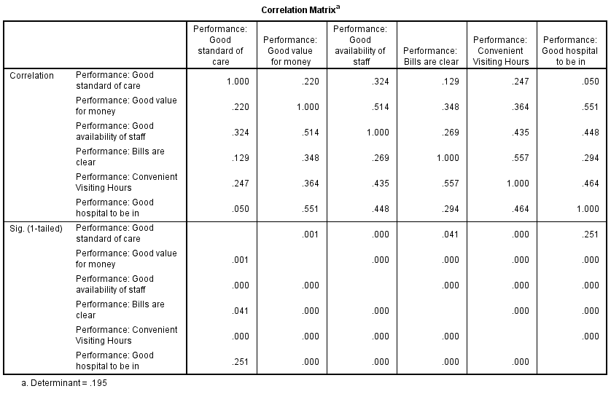
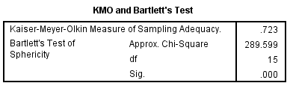  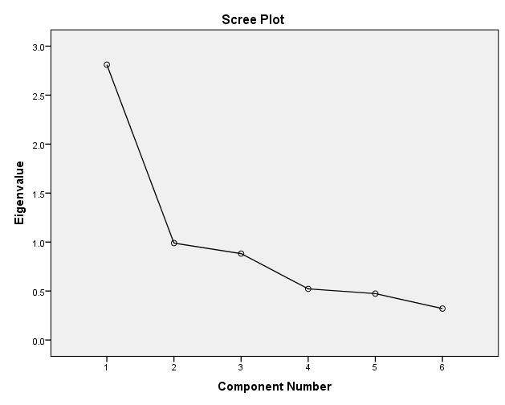 | 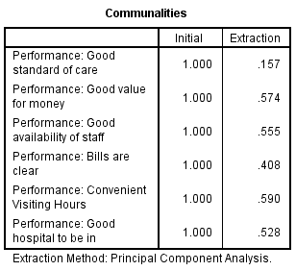
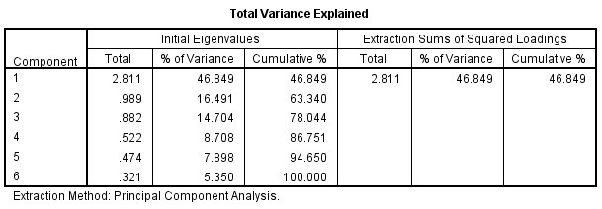 |  |  | 